

EE 463

Electromechanical Energy Conversion

Term Project: DC Motor Driver

Project Report

Hakan Polat 2031243

Yunus Emre Balcıoğlu 1936376

Mert Karaçelebi 2030930

1. Introduction

In this project we are asked to design a DC Motor driver. In this report the implementation procedure of a DC Motor driver will be explained in detail. In the first part of the report the problems will be listed. In the second part the solution possibilities, their advantages and disadvantages will be discussed. Then in the 4th part the simulation for the choosen solution will be performed. In the 5th part a theoretical lumped parameter termal analysis will be made. According to the solution, simulations and thermal analysis the required equipment will be selected and explained more in detail. After the choice of equipment the implementation procedure will be explained and results of the design will be given. In the comment part any deviation from the theory and encountered problems will be discussed in detail and in the conclusion part a short summary of the Project will be made.

1. Project Definition

In this Project we are required to implement a controlled rectifier. Our input is 3 phase AC (i.e 400 Vl-l and frequency = 50 Hz) and our output is an adjustable DC output. The motor that will be driven is in Figure 1 and its specs are in Figure 2.

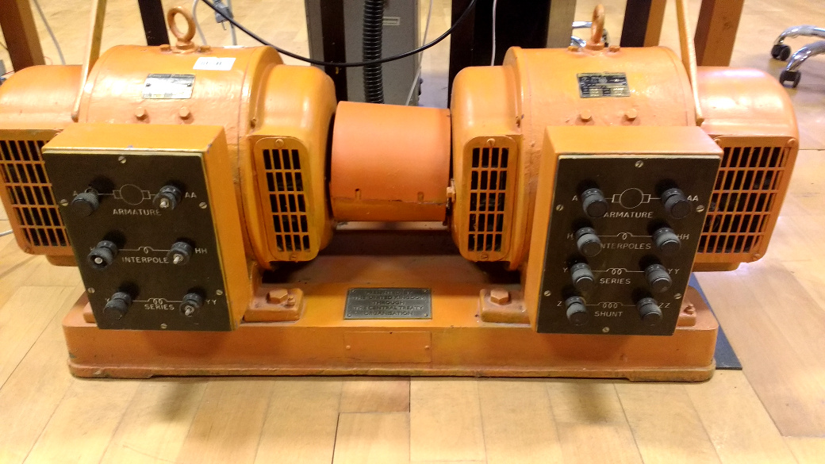

Figure 1: The image of the motor.

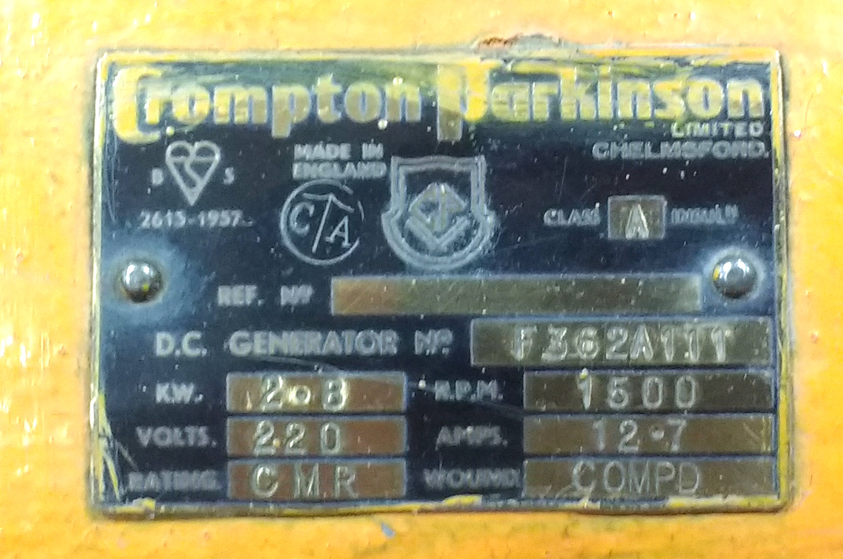

Figure 2: Rated values of the DC motor in Figure 1

* Armature Winding: 28 Ω, 13.3 mH
* Series Winding: 65 mΩ, 260 uH
* Shunt Winding: 8.26 kΩ, 6.4 H
* [Interpoles](https://www.quora.com/Electrical-Machines-What-do-interpoles-do-in-DC-motors) Winding: 0.8 Ω, 5.8 mH

The connection impedance values are as above. In this Project we need to drive the motor under no load however as a bonus we also did under full load (2.8kW).

1. Solutions

During lecture hours we learned about diode, thyristor rectifiers and buck,boost and buck-boost converters. Since we are required to implement a controlled rectifier we have mainly 3 solutions.

* 3 Phase thyristor rectifier

The three phase thyristor rectifier requires 6 thyristors a DC-link capacitor, 6 gate driver circuits and a controller unit. It may be preferable over 1 phase thyristor rectifier since 3 phase rectifier output is more similar to a DC output. However implementing the gate driver circuit and the controller unit is a serious problem and challenge for our design. Also the firing angles should be syncronized with the phases.

* 3 Phase Diode rectifier+ Buck Converter

This solution requires a three phase diode rectifier, an IGBT, a diode, a DC link capacitor, gate driver circuit and a controller unit. This solution seems the easiest to implement since it requires only a single gate driver circuit and there is no other gate driver hence no syncronization problem like in the thyristor case.

* 3 Phase Diode + Boost Converter

This solution is similar to the solution with the buck converter however since what we are trying to control is the current input to the motor a boost converter is not preferable since boost converter increases the voltage however it reduces the current input.

Taking all solutions into concideration we decided to use a 3 phase diode rectifier + a buck converter.

* Gate Driver

In all of our solutions we require a gate driver circuit. Since micro controllers are prone to high voltage an isolation is necessary. We are planning to use an optocoupler (TLP250 or HCPL3120) for our gate driver circuit. Also we require a floating voltage source since we should have a junction voltage or a Vgs voltage above the treshhold for PWM input. Hence an optocoupler satisfies our needs. As for the microcontroller we are planning to use Arduino. Although it is high in cost, for learning purposes it gives the flexibility of easy pwm generation and frequency and duty cycle adjustment. The circuit of the gate driver is in Figure 3.

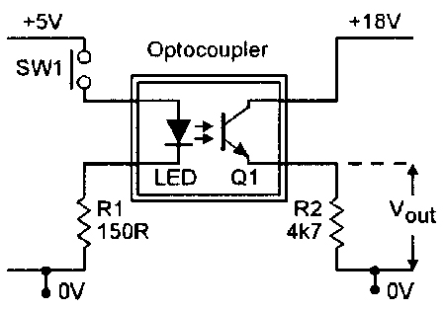

Figure 3: Gate driver using an optocoupler.

The PWM generated is connected to the left side of the optocoupler in Figure 3 (Led side).

External power is supplied from a DC power supply and the Vout is connected to the gate where the 0 V reference point is connected to the source( if MOSFET) or emitter (IGBT) or anode(thyristor). The 150 ohm resistance in the controller side is for protection. Also a 100nF capacitor is connected between 18V and 0V for noise reduction. The external gate resistance is around 20 ohms.

* PWM Generation

The Arduino should generate a PWM signal for our solution. However Arduino is a simple PWM code does not work under high frequencies. Therefore a manipulation of the the Arduinos clock is necessary.

int POT = A0;

int PWM =13;

float Duty=0;

float D=0;

int divisor = 64;

void setup() {

Serial.begin(9600);

pinMode(PWM,OUTPUT);

pinMode(POT,INPUT);

TCCR2B = TCCR2B & B11111000 | B00000010; // set timer 2 divisor to 8 for PWM frequency of 3921.16 Hz

}

void loop() {

D=analogRead(POT);

if (D<10){

D=0;

Serial.print("****");

}

Duty=D/1024*255;

analogWrite(PWM,Duty);

delay(2000);

Serial.print("The duty cycle is:");

Serial.println(D) ;

}

This arduino code takes voltage input from a potantiometer and gives an adjustable PWM with a frequency of 3900 Hz. The output pin is 13.

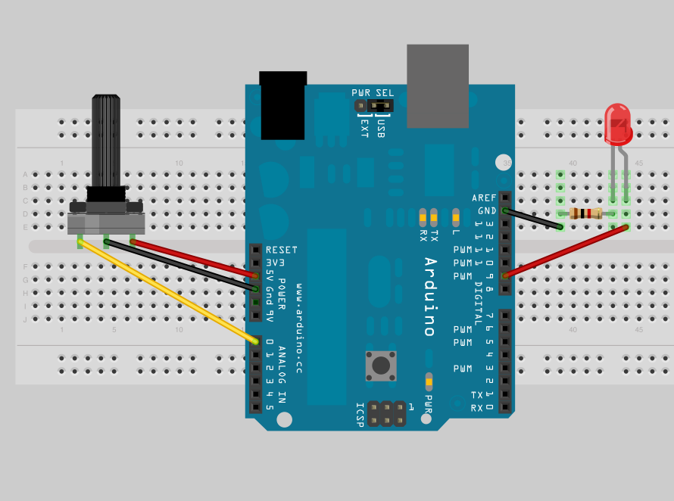

Figure 4: A sample Arduino connection

A sample Arduino connection is in Figure 4. The voltage input is taken from Analog 0 and PWM output is from PIN13. The led in Figure 4 is the led in gate driver circuit in Figure 3.

1. Simulation Results

In this part simulations will be made using MATLAB Simulink for several extreme cases like very low duty cycle and high duty cycle for equipment selection. During the simulations the gate driver circuit is replaced with a logic PWM signal.

The schematic for the simulation is in Figure 5.

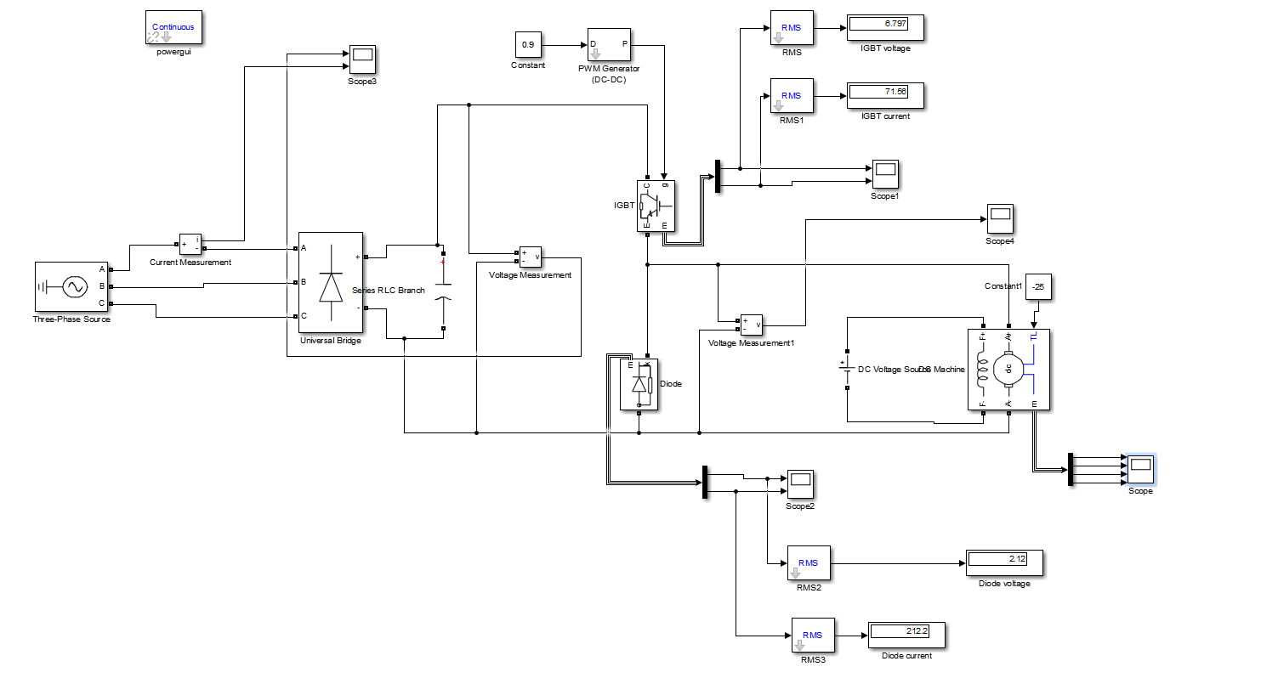

Figure 5: Simulink Schematic for the converter simulation

In order to choose the proper equipment we investigated 3 different cases where the duty cycle is 1, 0.50 and 0.05. Using this approach we can find the rated values for each component.

* PWM Duty Cycle =1

The line voltage is adjusted such that the DC output rms is 220 V.

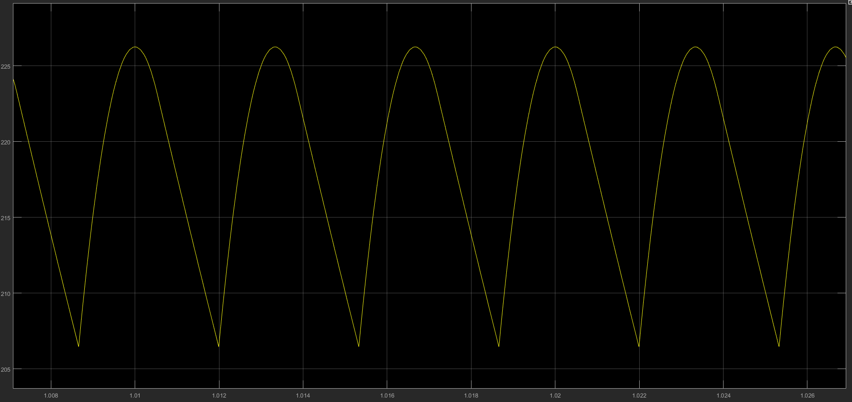

Figure 6: Voltage of the DC-link Capacitor i.e DC voltage input of the Buck Converter

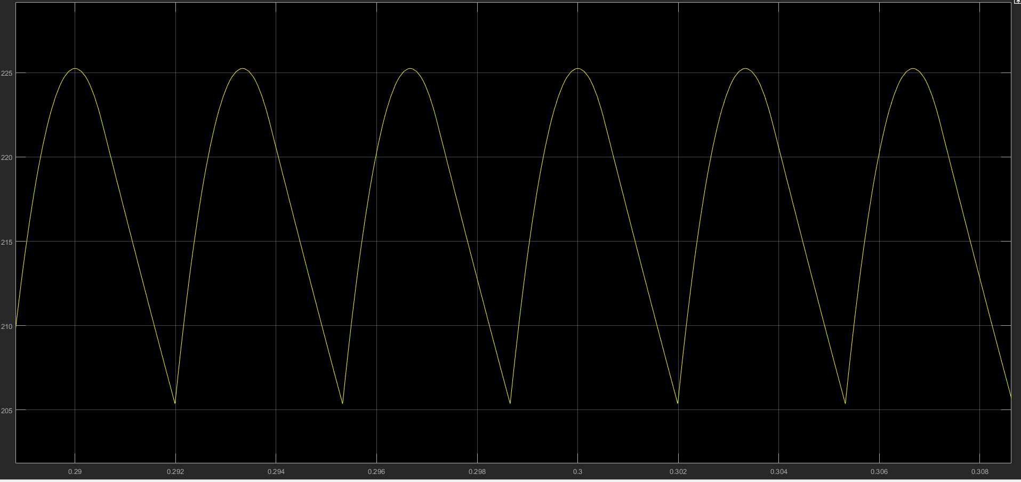

Figure 7: Motor Voltage

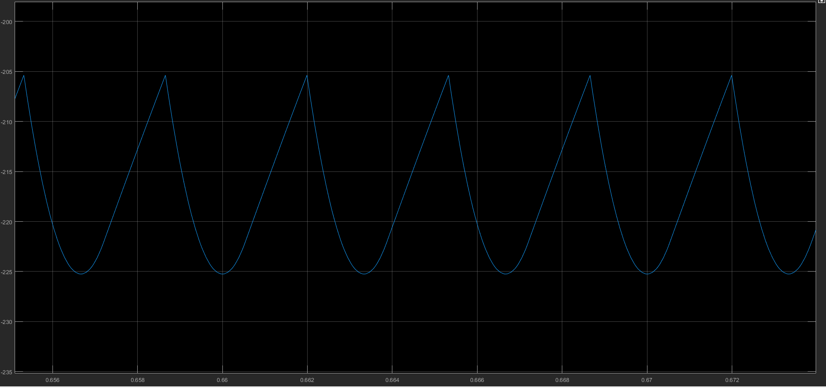

Figure 8: Diode Voltage

|  |  |
| --- | --- |
| IGBT Voltage RMS | 1 V |
| IGBT Current RMS | 7A |
| Diode Voltage RMS | -220V |
| Diode Current RMS | 0A |
| Capacitor Voltage RMS | 220V |
| 3 Phase Rectifier Voltage RMS | 220V |
| 3 Phase Rectifier line Current RMS | 9A |

* PWM Duty Cycle= 0.5

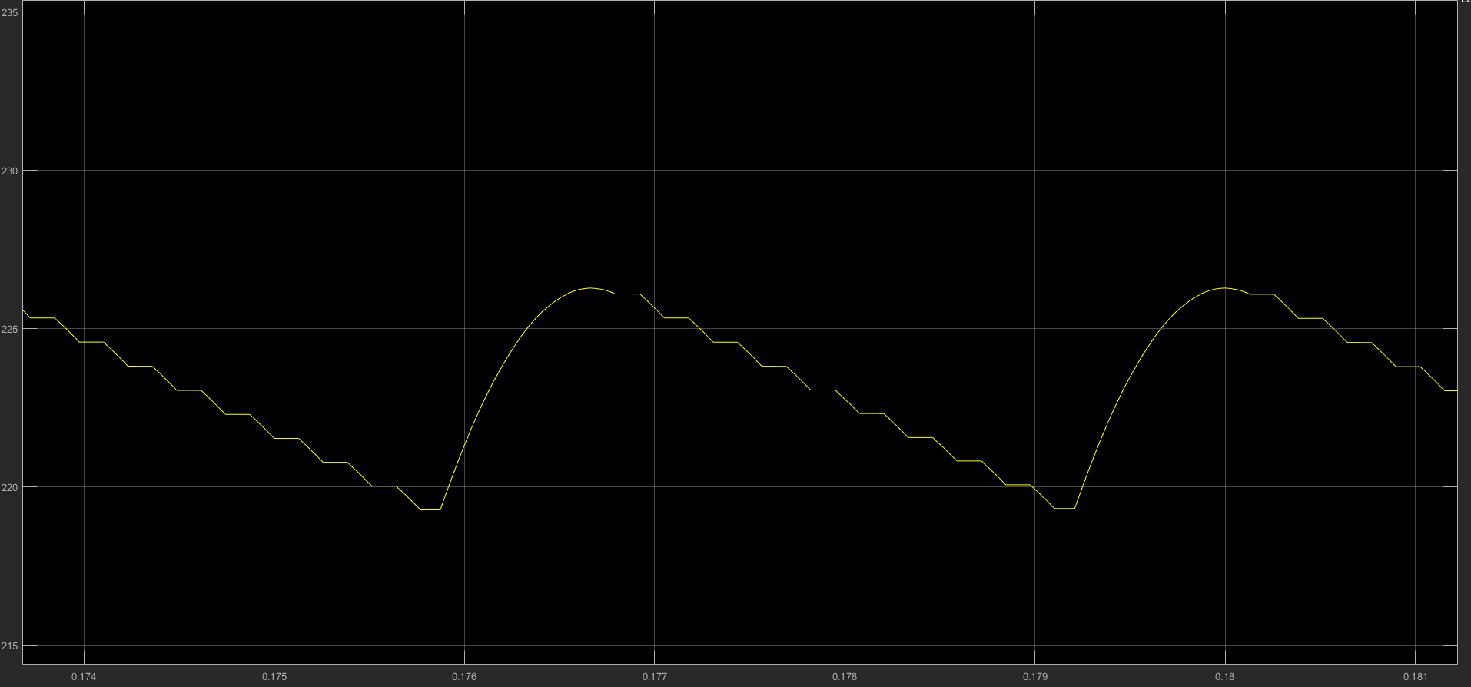

Figure 9: Voltage of the DC-link Capacitor i.e DC voltage input of the Buck Converter

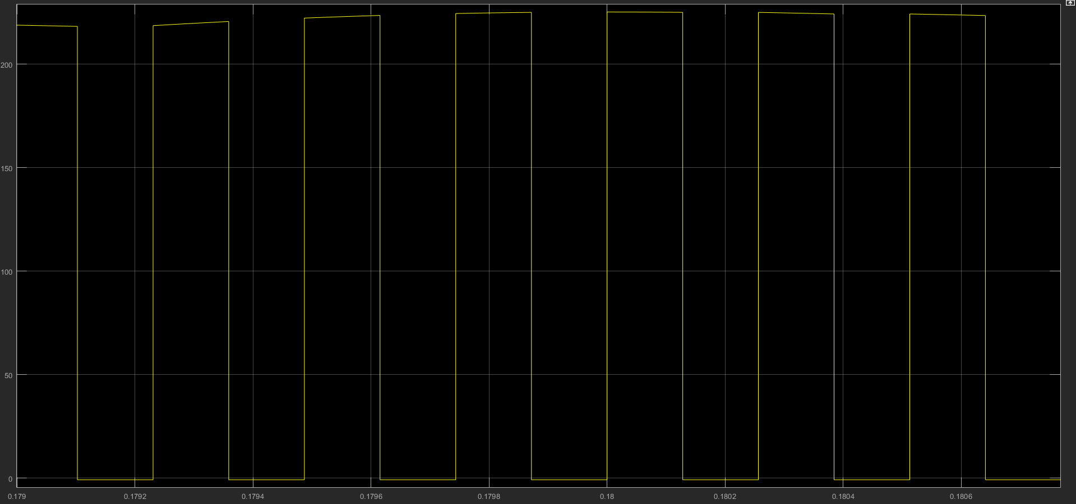

Figure 10: Motor Voltage

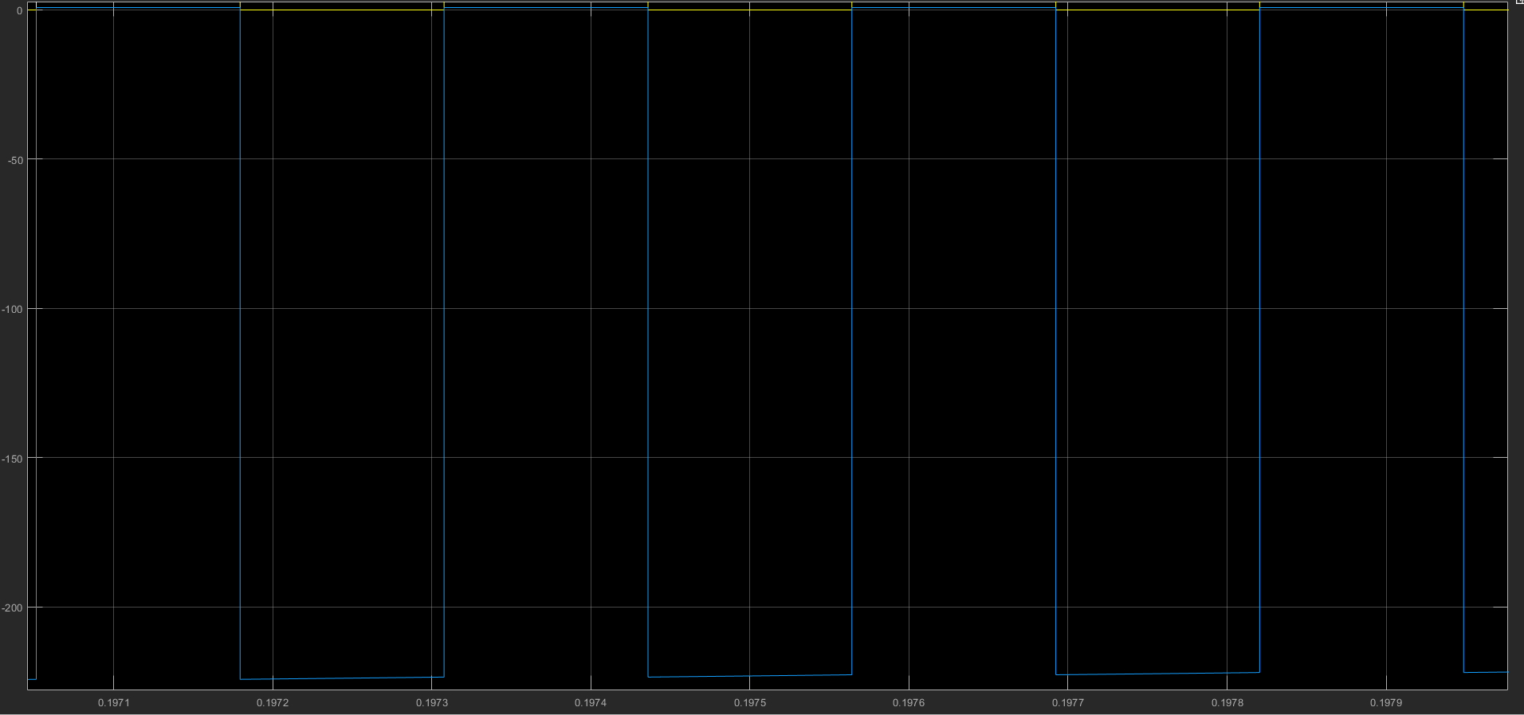

Figure 11: Diode Voltage

|  |  |
| --- | --- |
| IGBT Voltage RMS | 156 V |
| IGBT Current RMS | 3 A |
| Diode Voltage RMS | -155 V |
| Diode Current RMS | 2.26 A |
| Capacitor Voltage RMS | 220 V |
| 3 Phase Rectifier Voltage RMS | 220 V |
| 3 Phase Rectifier line Current RMS | 3.8 A |

* PWM Duty Cycle= 0

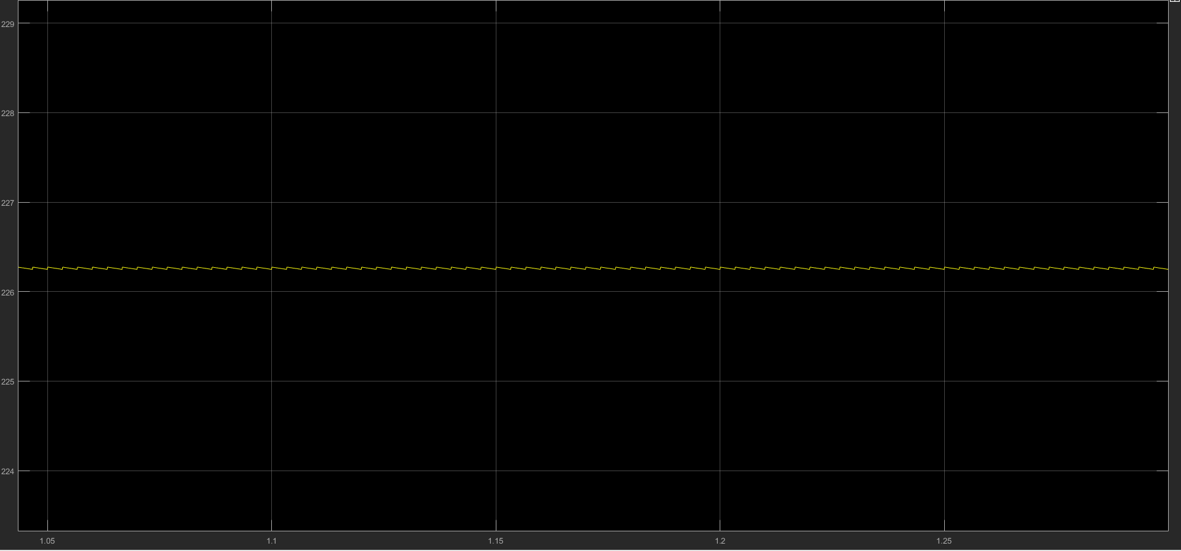

Figure 12: Voltage of the DC-link Capacitor i.e DC voltage input of the Buck Converter

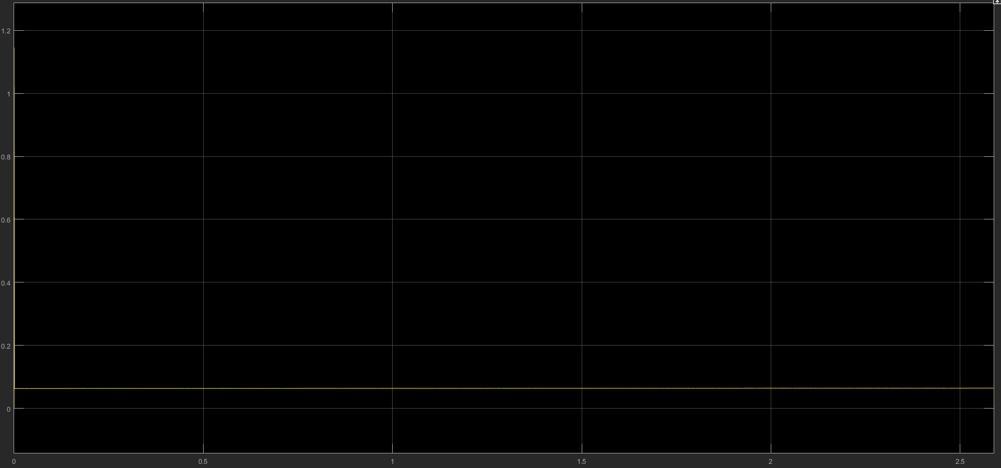

Figure 13: Motor Voltage

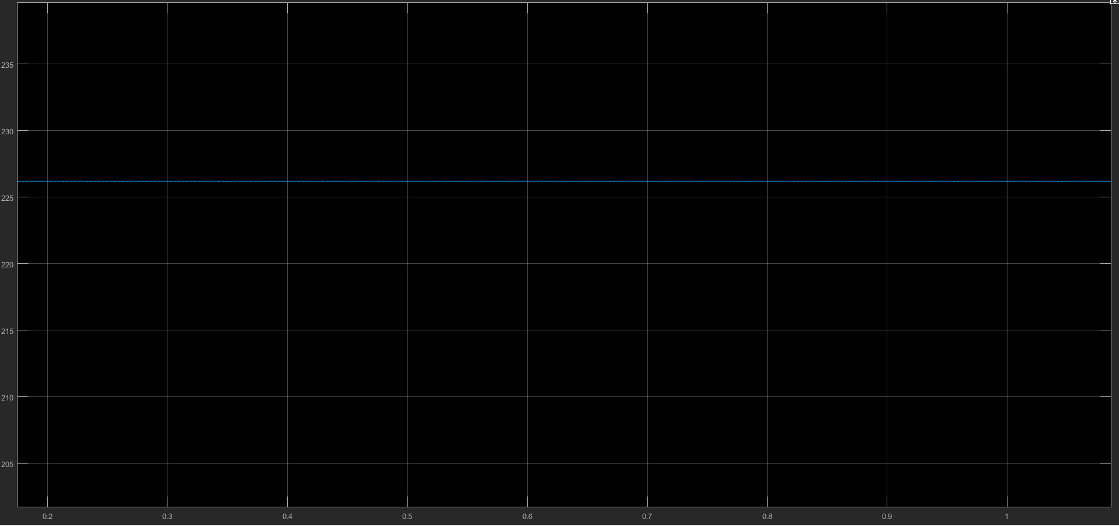

Figure 14: IGBT Voltage

|  |  |
| --- | --- |
| IGBT Voltage RMS | 220 V |
| IGBT Current RMS | 0 A |
| Diode Voltage RMS | 0 V |
| Diode Current RMS | 0 A |
| Capacitor Voltage RMS | 220 V |
| 3 Phase Rectifier Voltage RMS | 220 V |
| 3 Phase Rectifier line Current RMS | 0 A |

According to the simulations the equipment rated values should be above

|  |  |
| --- | --- |
| IGBT Voltage RMS | 220 V |
| IGBT Current RMS | 7 A |
| Diode Voltage RMS | 220 V |
| Diode Current RMS | 7 A |
| Capacitor Voltage RMS | 220 V |
| 3 Phase Rectifier Voltage RMS | 220 V |
| 3 Phase Rectifier line Current RMS | 9 A |

For safety 1.5x of every rated value would keep us on the safe side.

1. Equipment Selection

After finding the rated value for equipment we can select our products. We investigated the several websites as Farnell or Texas Instruments. However those sites have shipping rates which is really expensive and delivery time is long. We selected our supplier as “Yıldırım Elektronik” which is located at center of the Ankara and prices are reasonable.

Our first fundamental component is 3 phase diode rectifier. For diode rectification we have two options. First option is construct the rectifier using 6 separate diodes. Second option is using a glass passivated bridge rectifier, that is a commercial product and more reliable, also cheaper than separate 6 diodes. That’s why we selected a three phase passivated bridge rectifier. At appendix A, one can find the related link to our product datasheet. In figure 15, one can find the picture of our rectifier.

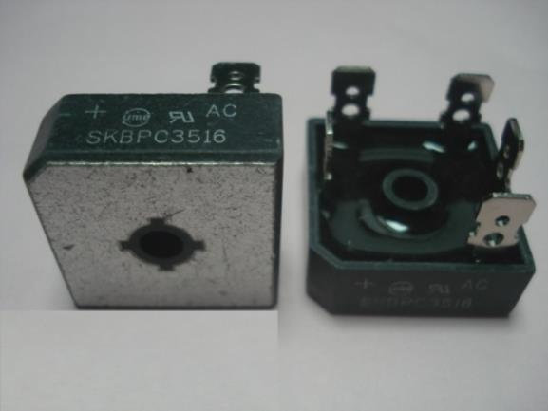

Figure 15: Picture of SKBPC3516

As one can see from the picture size of the rectifier is suitable and easy to make connections. In figure 16 one can find the rated values which we used in selection processes.

|  |  |  |  |
| --- | --- | --- | --- |
| Parameter | Condition | Value | Unit |
| Repetitive Peak Reverse Voltage |  | 1600 | Volts |
| Average Rectified Output Current | With Heatsink at 55 Celsius/ 60 Hz sine wave with RL load | 35 | Amperes |
| Junction Temperature |  | -40 to 150 | Celsius |
| Thermal Resistance | Between Junction and Case with Heatsink | 1.35 | °C/W |

Figure 16: Related Rated Values

Peak reverse voltage breakdown is high above for our project, but when we considered the current capability we selected SKPBC3516. Thermal resistance is used while our thermal analysis section, our product’s thermal resistance smaller compared to other products.

Our Second equipment is DC Link capacitor. Compared to rectifier we have limited sources to obtain the capacitor for our rated values and we want to stay in safe side we selected our capacitor rating above the rated values. We selected “Kendeil “460 Volts, 680 µF capacitor. As one can see from its rating it is designed for compensation in low voltage systems but it is suitable for our project too. In figure 17 one can find the picture of capacitor.

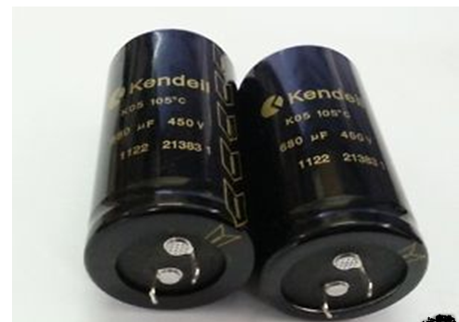

Figure 17: Picture of Kendeil Capacitor

ESR losses of capacitor is relatively low compared to series connected several capacitors. Buying several small capacitors compared to our product will be cheaper but for low loss and reliability we selected large capacitor.

Our next component is our switching transistor. First we used Mosfet transistors for switching purposes but we realized reliability issues occurred while operating at rush current regions of the motor in addition to this conduction, switching losses are higher than its peer IGBT. Compared to IGBT and Mosfet, IGBT has some disadvantages such as hard to drive its gate and expensive. However it is more reliable and less lossy than Mosfet. In figure 18, one can find the IXGH 32N90B2 IGBT transistor.

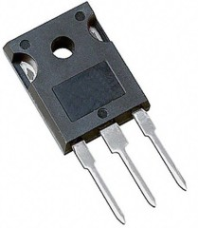

Figure 18: IGBT IXGH32N90B2

In figure 19 one can find the related information about the transistor.

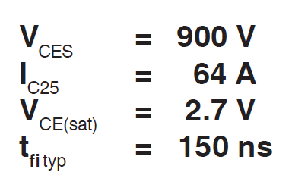

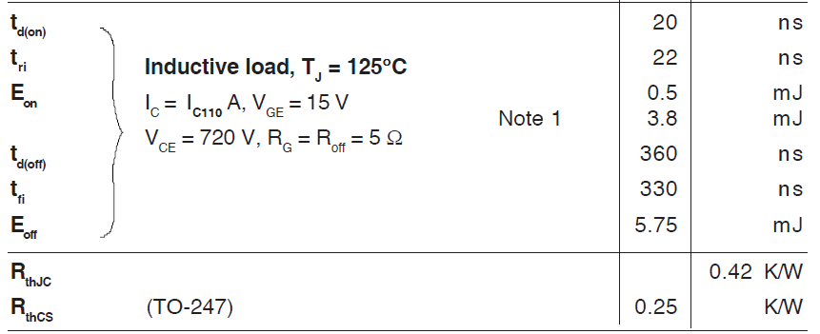

Figure 19: Ratings of IGBT

First we investigate our ratings, it can be seen as an overdesign for this project but for safety reasons and to increase the lifetime of operation, this IGBT is suitable. Thermal resistances and switching losses are important for thermal analysis procedure.

Our next component is freewheeling diode. Since we are operating around 4 kHz switching frequency, we used Fast Recovery Epitaxial Diode (FRED) DSEI30-12A. At off stage of the switch all motor current will circulate through the freewheeling diode therefore current/voltage rating of diode must be equal or higher than the motor ratings. In Figure 20, one can find the picture of diode.

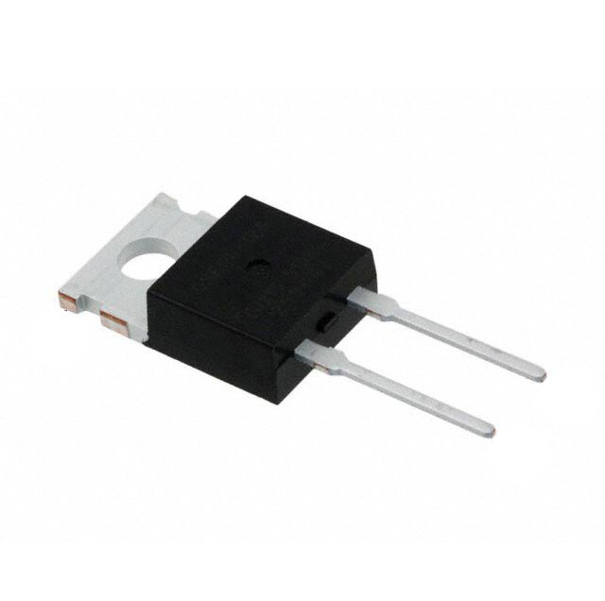

Figure 20: Picture of DSEI30-12A

In figure 21 one can find the related information about the diode.

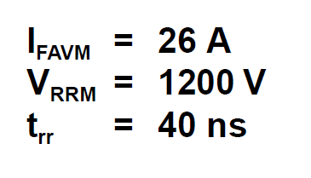

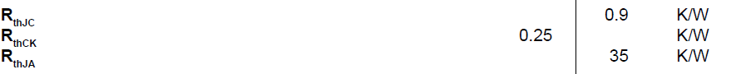

Figure 21: Ratings of the diode

As one can see from the ratings current capability and voltage limit is high enough for operation. Also rise time is small enough compared to our switching frequency. Other parameters will be used during thermal analysis.

Our next component will be optocoupler HCPL 3120.Optocoupler is used for isolation between micro controller and gate driver circuit. In figure 22 one can find the picture of HCPL 3120 and in figure 23 one can find the ratings of the device.

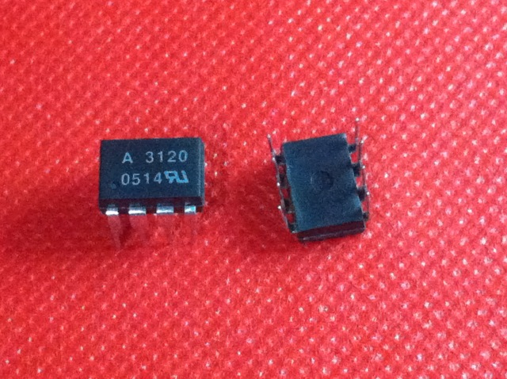

Figure 22: Picture of HLCP 3120

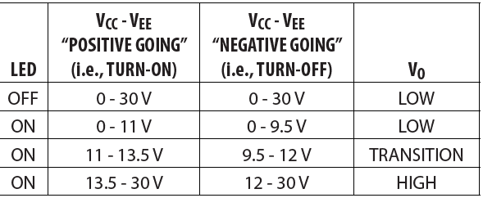

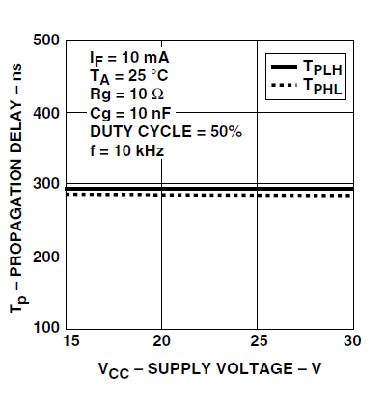

Figure 23: Related Information about HLCP 3120

As one can observe from the figure 23, propagation delay is relatively small compared to switching period. Also one can see the opening and closing regions of the optocoupler. We can get the High output when led is on and fed through the DC supply.

Our final equipment is a micro controller. For this project we used Arduino Mega but any microcontroller with fast clock cycle can be used for this purpose. Because only work of Arduino is, adapting the PWM signal according to measured voltage from the potentiometer.

1. Thermal Analysis
2. Results

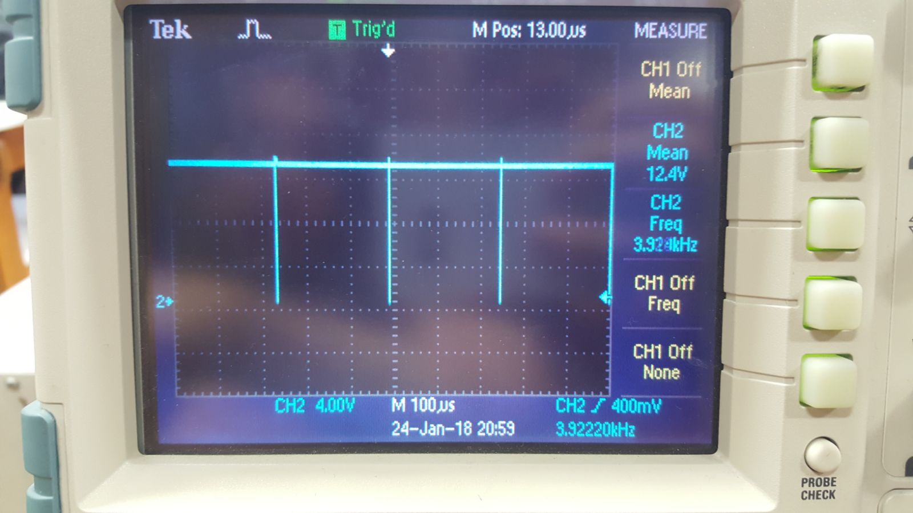

Figure 24: Optocoupler output voltage at 3.9kHz and 100% Duty Cycle

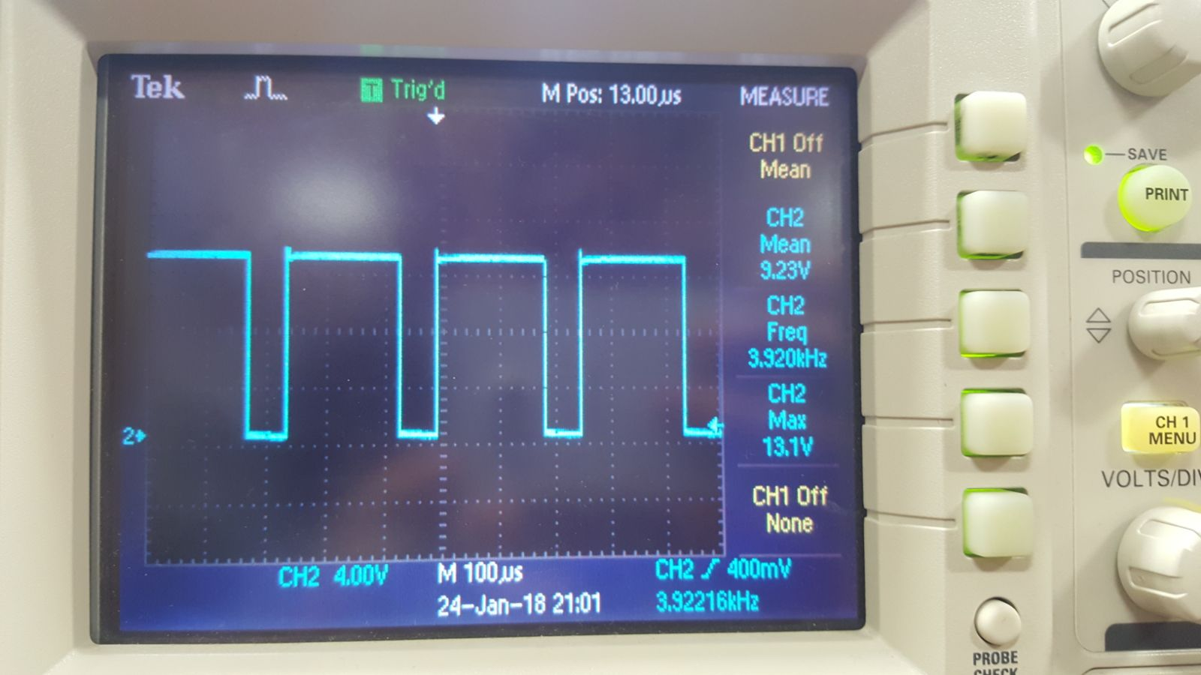

Figure 25: Optocoupler output voltage at 3.9kHz and 75% Duty Cycle

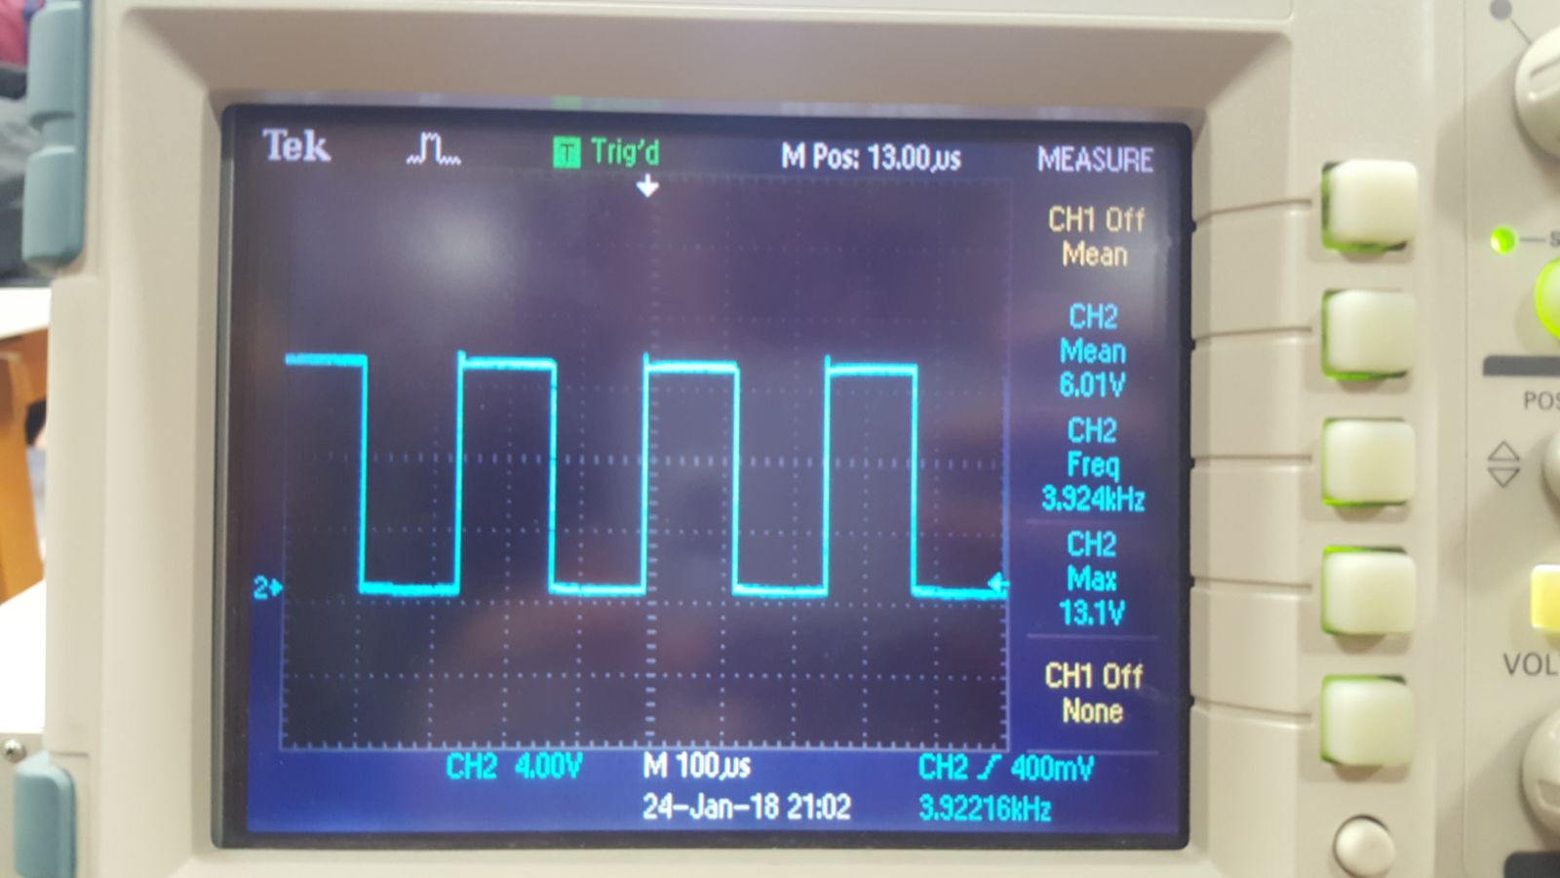

Figure 26: Optocoupler output voltage at 3.9kHz and 50% Duty Cycle

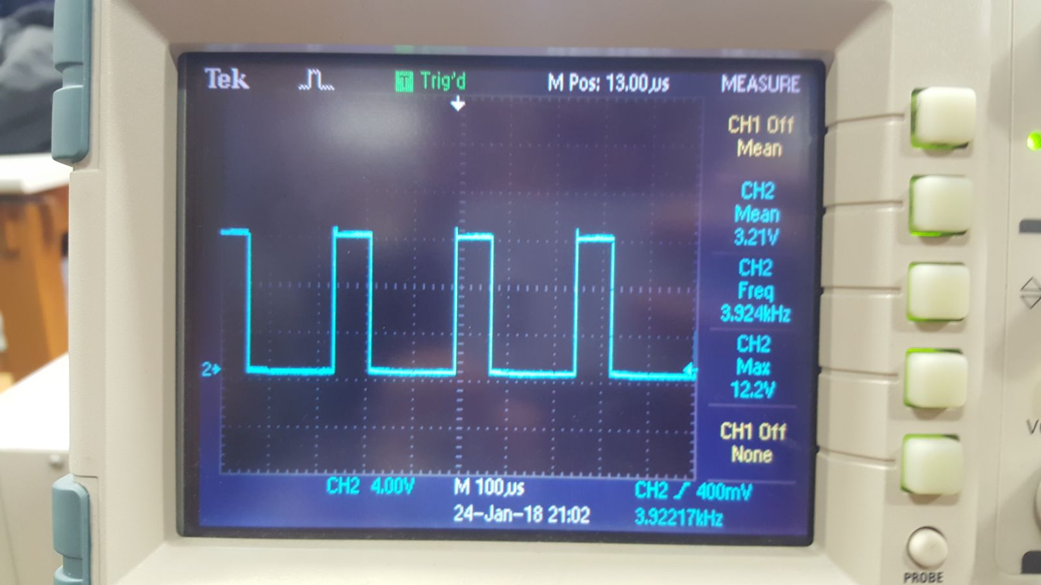

Figure 27: Optocoupler output voltage at 3.9kHz and 25% Duty Cycle

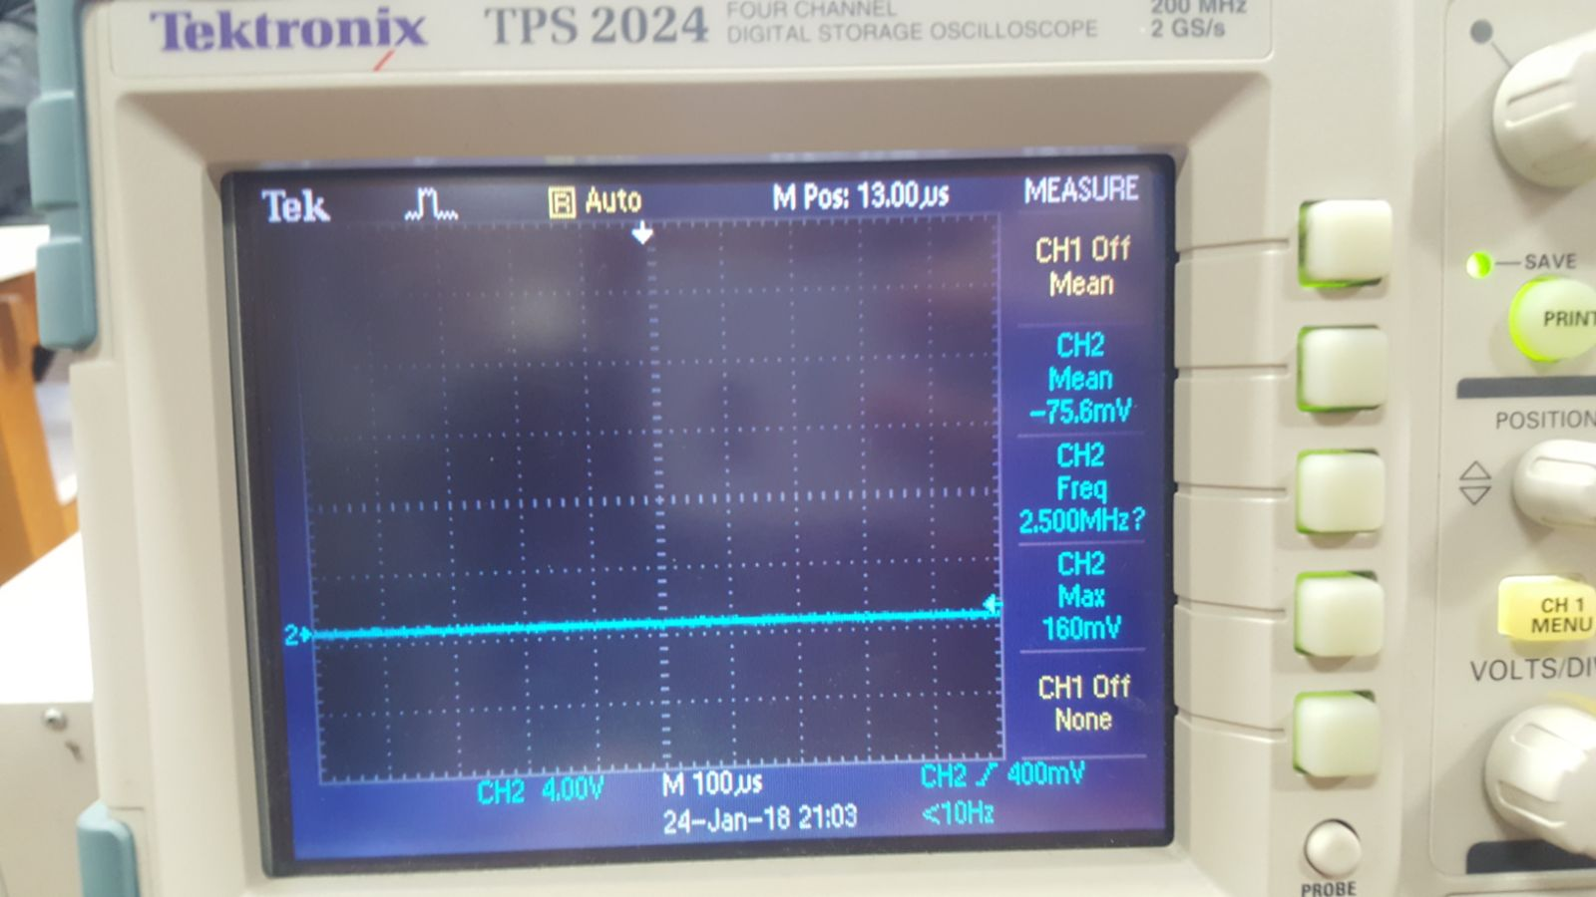

Figure 28: Optocoupler output voltage at 3.9kHz and 0% Duty Cycle

We got optocoupler outputs as shown above. Output waveforms are sufficient for our aim which is to control output voltage of buck converter. Frequency of duty cycles are 3.924 kHZ.

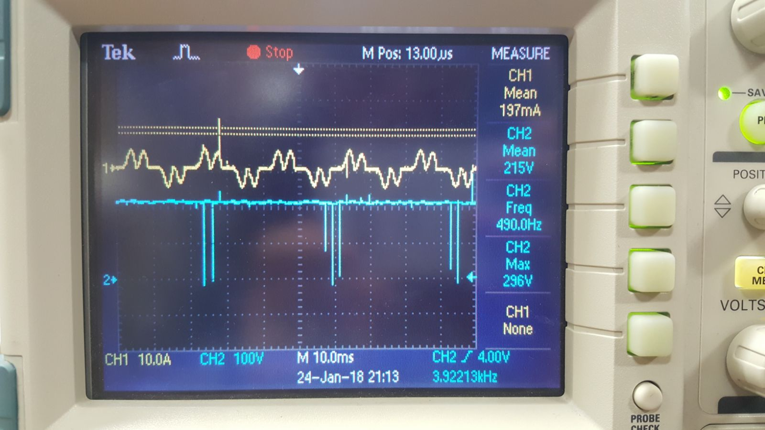

Figure 29: DC motor armature terminal voltage and line current wave forms at 100% Duty Cycle

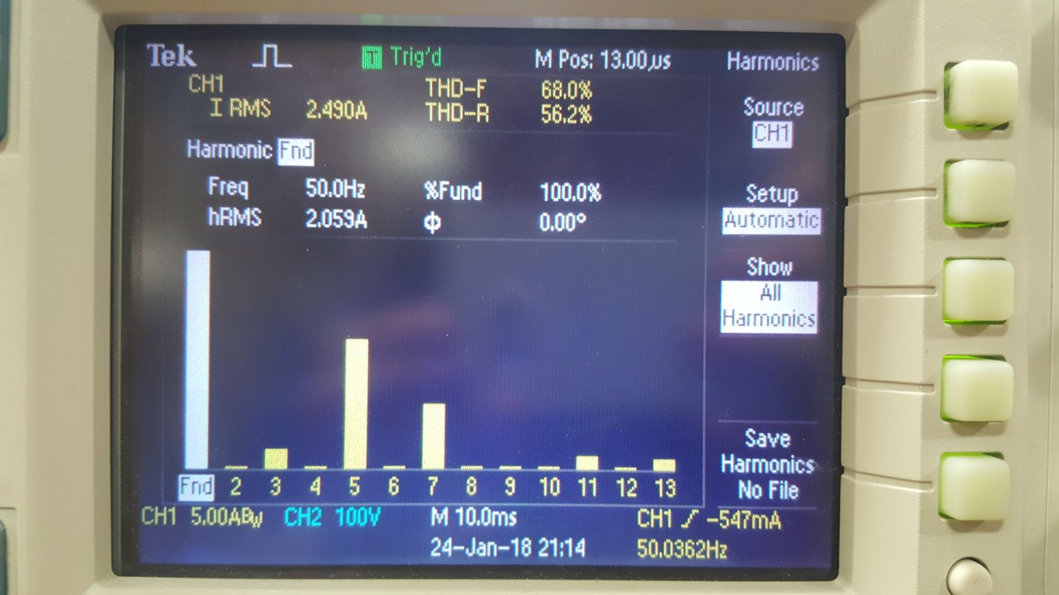

Figure 30: Line current THD values at 100% Duty Cycle

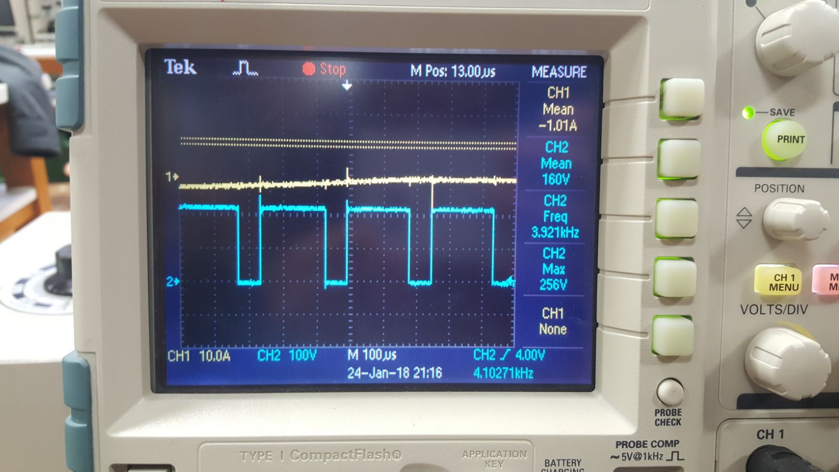

Figure 31: DC motor armature terminal voltage wave form at 75% Duty Cycle

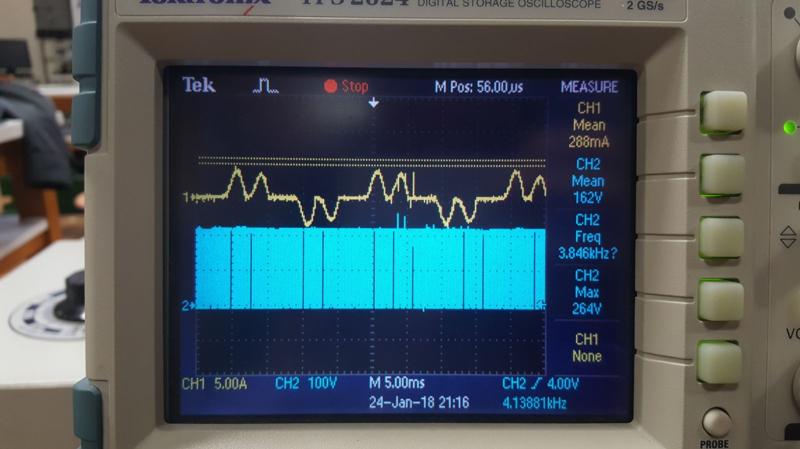

Figure 32: Line current wave form at 75% Duty Cycle

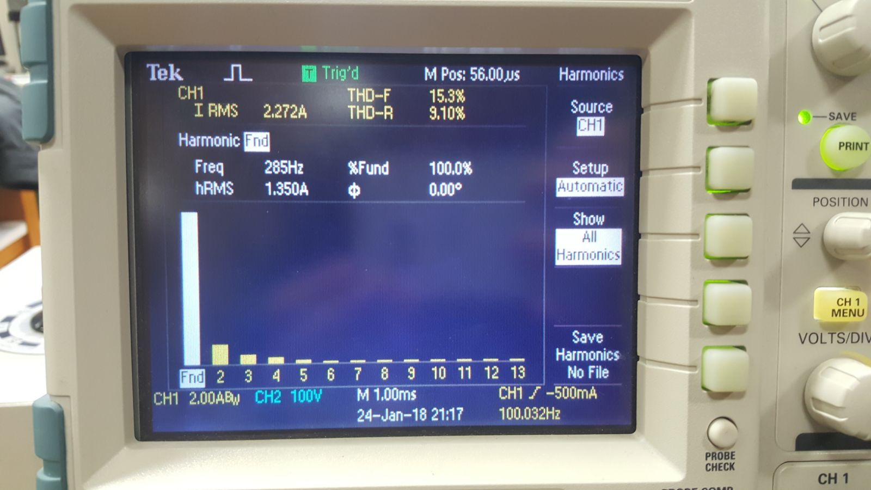

Figure 33: Line current THD values at 75% Duty Cycle

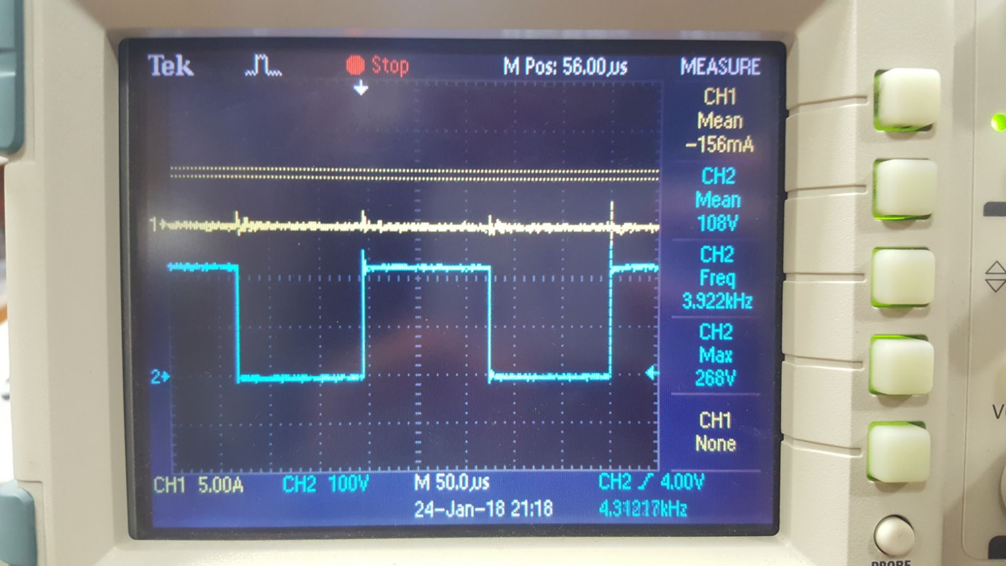

Figure 34: DC motor armature terminal voltage wave form at 50% Duty Cycle

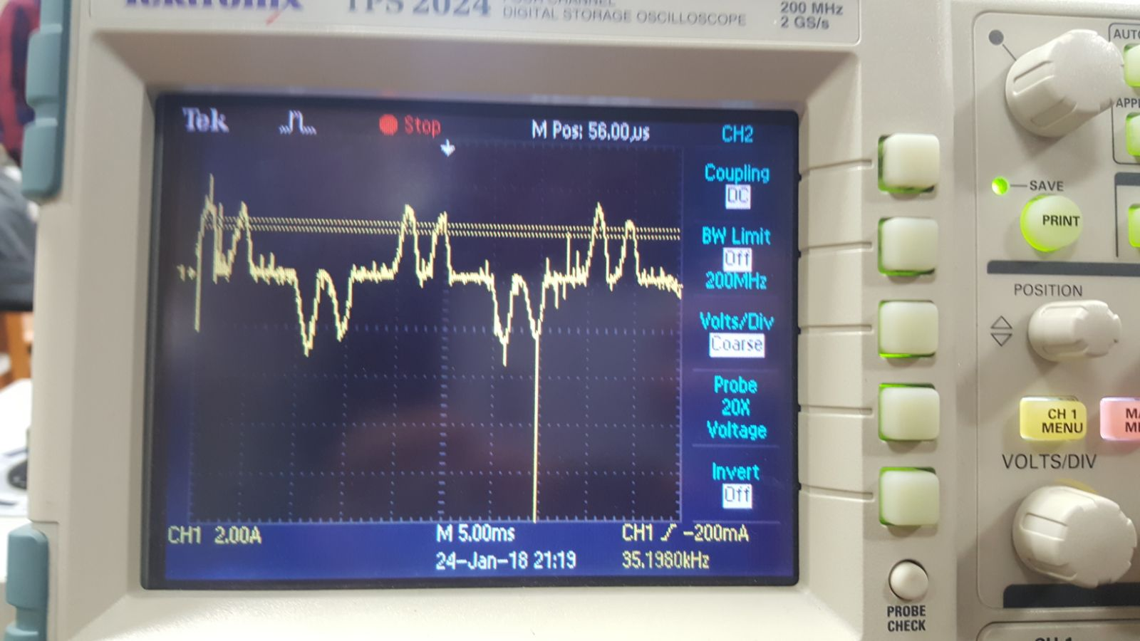

Figure 35: Line current wave form at 50% Duty Cycle

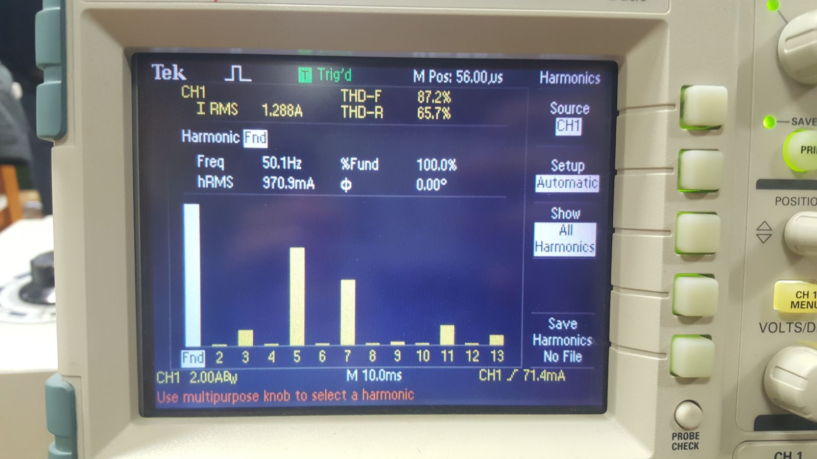

Figure 36: Line current THD values at 50% Duty Cycle

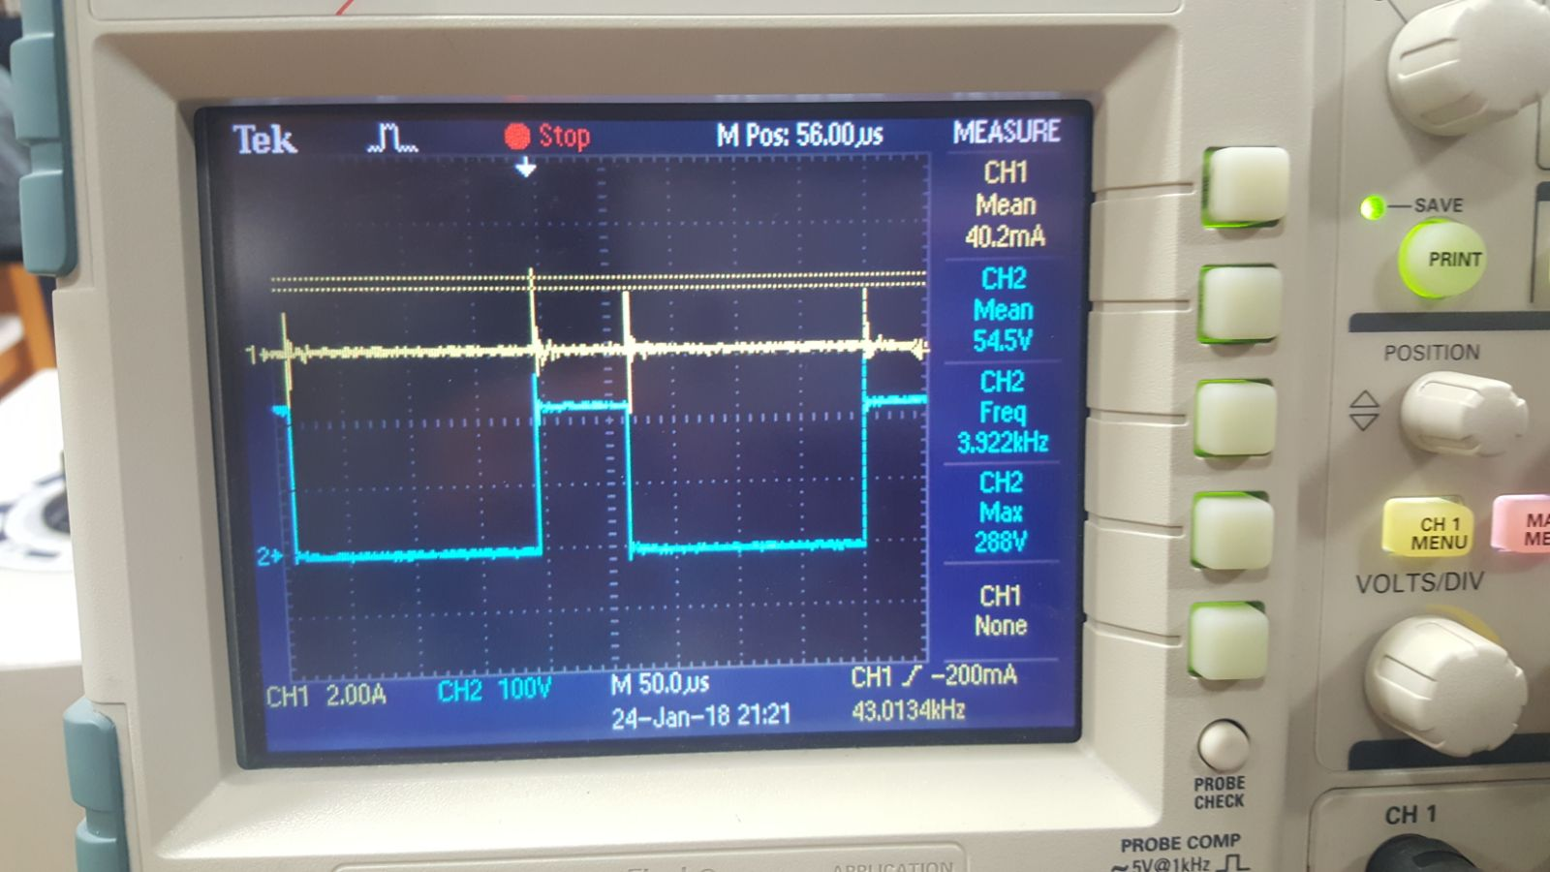

Figure 37: DC motor armature terminal voltage wave form at 25% Duty Cycle

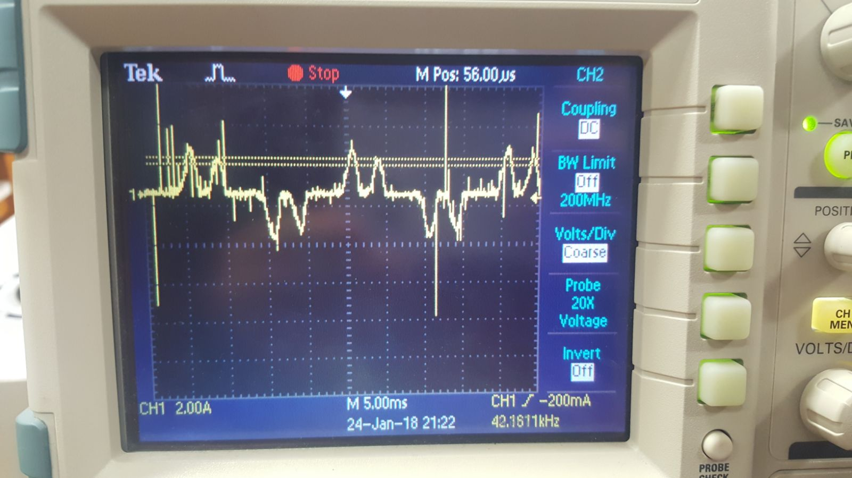

Figure 38: Line current wave form at 25% Duty Cycle

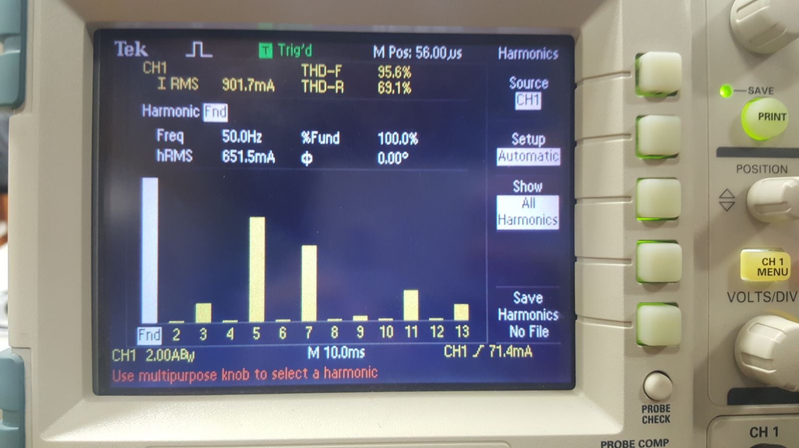

Figure 39: Line current THD values at 25% Duty Cycle

|  |  |  |  |  |
| --- | --- | --- | --- | --- |
| Duty Cycle | Mean of motor voltage(V) | Line current(ARMS) | Line current THD-F (%) | Motor speed(rpm) |
| 100% | 215 | 2.49 | 68 | 1500 |
| 75% | 160 | 2.27 | 15.3 | 1336 |
| 50% | 108 | 1.29 | 87.2 | 1204 |
| 25% | 54.5 | 0.9 | 95.6 | 990 |

For %75 duty cycle line current THD value is 15.3%. Most probably, we got wrong result. When measuring these datas, field terminal of DC motor is powered by armature terminal of DC motor. Line current is measured 8 A due to this reason, and did not changed significantly. We measured armature current by using analog amperemeter. When duty cycle is decreases, armature voltage decreased as expected, and result of this motor speed is decreased. Motor output power is Torque*MotorSpeed.

PIN – PLOSS = POUT

We did our measurements at no load, and output torque was constant, so when motor speed is decreased, Pout  also decreased. If we assume PLOSS is constant, and VIN is constant. This situation explains why line current decrease when motor speed and duty cycle decreased.

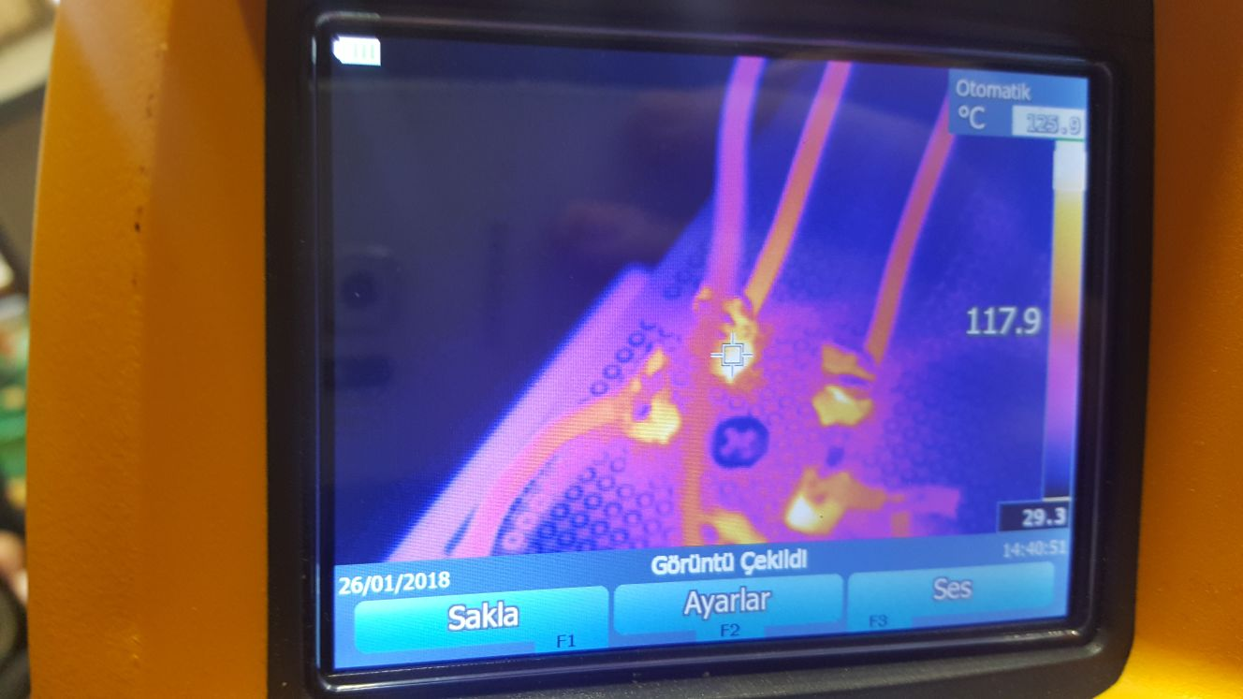

Figure 40: Thermal photograph of 3-phase bridge rectifier

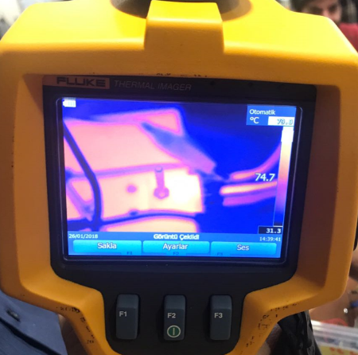

Figure 41: Thermal photograph of IGBT

These thermal photographs are taken under DC motor full load working period. 3-phase bridge rectifier is at 117.9 degree, and IGBT is at 74.7 degree. During DC motor no load working period highest temperature of components was 43 degree. When full load working period motor draws 12 A. It results this temperature increase.

1. Comments
2. Conclusion